Street Reach are now recruiting Volunteers!

Volunteers
Winchester Street Reach are looking to recruit Volunteers to join our team, working out in the local community and leading a range of exciting projects. Bring your skills and interests to the role and help support and empower young people to reach their full potential!
We are looking for confident candidates with strong communication skills and who can help offer support and guidance to young people as part of the Street Reach team. You do not have to have held the position of Youth Worker before, but you will be a confident communicator, have a passion for working with young people and be able to inspire them. Full training is provided.
This is a unique and rewarding role with part-time hours to fit around your other commitments. The work will be based in Winchester and surrounding areas.

Current Volunteer Vacancies:

Youth Worker roles:

Detached Volunteer Youth Worker
Mondays 6 – 9pm or Tuesdays 6 – 8:30pm

Micheldever Youth Club- Volunteer Youth Worker
Mondays 6:45 – 9:15pm

Friday Football- Volunteer Youth Worker
Fridays 5:30 – 8pm

Administration Volunteer
Get experience in an expanding youth charity and gain an insight into the processes that make the charity’s work possible. You will play a crucial role in providing essential support to the organisation's administrative functions.

The role will involve general administrative duties, supporting the finance team, the Operations Manager, Marketing Lead and the fundraising team in various capacities. You could help us out at our events and other activities as well.

Community and Fundraising Volunteer
As a Community and Fundraising Volunteer at Winchester Street Reach, a dynamic and expanding youth charity in Winchester, you will play a pivotal role in engaging with the local community and helping raise vital funds for the organisation's growth.

You will have the opportunity to develop and implement innovative strategies to connect with individuals, businesses, and community groups, fostering partnerships and collaborations to support the charity's mission.

Marketing Volunteer
As a Marketing Volunteer at Winchester Street Reach, an expanding youth charity in Winchester, you will play a vital role in raising awareness and promoting the organisation's mission through creative marketing strategies while supporting the Social Media and Marketing Lead. Your responsibilities will include developing engaging content for various platforms, including social media, and the organisation’s website. You will have the opportunity to showcase your content creation skills by creating compelling videos and marketing material that effectively communicate the impact of Winchester Street Reach's work.

The specific timing and schedule for these roles can be determined at a later stage, based on mutual agreement and availability.

Agreed transport expenses will be re-reimbursed, these are subject to conditions.

Successful applicants will be required to undergo an Enhanced DBS check.

Application Deadline: Ongoing

For further details and an application pack visit: www.winchesterstreetreach.org/support-us or contact us on 01962 828621

Winchester Street Reach, Registered Charity No. 1167148.

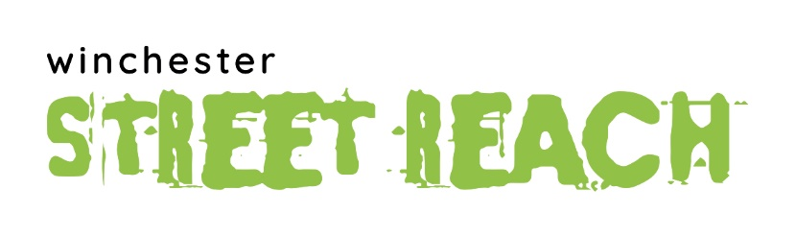
Registered Charity Number 1167148

Application Form for VOLUNTEER Post

Please indicate where you saw this vacancy advertised ________________________________

Please complete in black ink or typing. Please do not send a separate CV

Personal details

Surname______________________________Forenames___________________________________

Address_______________________________________________________________________

_____________________________________________________________________________

_____________________________________________________________________________

Contact telephone number:_____________________________

Email________________________________________________________________________

Educational and other relevant qualification and/or experience.
List courses attended

From To School/college Qualification

Employment record. Please start with your current employer and indicate any notice period
(if relevant, please include voluntary work / activities)

From To Employer/Organisation Position held

Indicate below any other aspects of your employment/voluntary work which you consider to be relevant to this application

Please state why you think that you would like this position and what you hope to bring to the post

Leisure interests

References
Please give contact details of two people who can provide information that will confirm your suitability for this post. If possible, one should be your current or recent employer and the other should be someone who has known you in a professional capacity.

Referee one Referee two

Name Name

Position Position

Address Address

Postcode Postcode

Telephone number Telephone number

E mail E mail

(i) Driving licence yes/no

(ii) Car owner yes/no

Note: it is not a requirement for this role to be a driver.

Declaration

I certify that the information given on this form is correct to the best of my knowledge, and that I have completed this declaration. I understand that this post is subject to a satisfactory Enhanced Disclosure Barring Service (DBS) check. If appointed, I understand that the information on this form will be computerised for employee administration purposes in accordance with the Data Protection Act 1984.

Signed_________________________________________________________________

Date___________________

To submit your application:
Please visit winchesterstreetreach.org and upload your completed form on the ’Support Us’ page.

Volunteer Youth Worker Job Description and Person Specification

Registered Charity Number 1167148

Job Description for Volunteer Youth Worker

Job summary:

Volunteer Youth Workers work alongside staff to help ensuring delivery of centre-based projects by Winchester Street Reach.

Volunteer Youth Workers will work alongside staff, providing a variety of challenging and exciting opportunities to enable them to develop personally and socially. Volunteer Youth Workers will help identify young people’s needs and will work with them within the Street Reach team to ensure their individual and group needs are addressed. They will advocate on behalf of young people and enable young people to represent themselves and make informed decisions on issues that affect them.

The Volunteer Youth Worker will work within the organisation’s policies and practices, and will give full regard to Child Protection issues and the rights of the individual.

The Volunteer Youth Worker will:

- Work as part of the Street Reach team, accountable to the Project Manager or Operational Lead.

- Work towards the empowerment of young people; ensuring they are able to represent themselves and make informed decisions on issues that affect them.

- Establish and build working relationships with young people.

- Offer guidance and support to young people.

- Identify needs of users, and work within the team to employ and implement strategies for meeting those needs.

- Work with young people using a variety of methods/mediums including arts/ sports/recreation to enable them to develop self awareness, self esteem and self confidence.

- Explore with the staff team, ways of working with young people who behave aggressively, abusively and anti-socially towards others.

- Input into team planning, and session recording/ evaluations

- Attend staff meetings where appropriate.

- Attend regular supervision sessions where appropriate.

- Undertake appropriate training.

- Work with local organisations as required.

Standard Terms Common to all Job Descriptions:

To promote Street Reach’s Equal Opportunities Policy.

- To comply with all Street Reach Policies and Conditions of Service.

- In discharging the duties of the post to have due regard to the provisions of Health & Safety legislation and Child Protection requirements.

- To undertake such additional responsibilities as required, which are commensurate with the post.

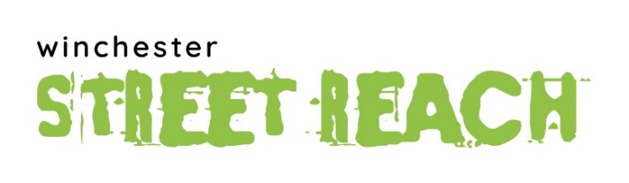
Registered Charity Number 1167148

Person Specification: Volunteer Youth Worker

Education & Qualifications

 | Essential | Desirable
5 GCSE’s at grades A* to C (grades 9 to 4), including Maths and English |  | X

Experience

 | Essential | Desirable
Previous experience of working with young people aged 11-17. either in a centre based or detached setting |  | X
Experience of working within a team | X
Experience of planning and delivering innovative work with young People |  | X
Experience of work in an inner urban area, with complex social needs and disadvantage |  | X
Experience of developing ways of increasing young people’s participation |  | X
Experience of working with voluntary and/or statutory agencies |  | X

Skills & Abilities

 | Essential | Desirable
Ability to establish and maintain positive relationships with young people | X
Ability to work with young people to develop their social education | X
Ability to work with young people individually and in groups | X
Ability to understand, follow and implement procedure | X
Ability to assist in the motivation, retention, development and support of staff and volunteers |  | X

Knowledge

 | Essential | Desirable
Knowledge of and ability to implement Equal Opportunities and anti-oppressive practice | X
Knowledge of key policies and current developments that affect work with young people |  | X

Work Circumstances

 | Essential | Desirable
Prepared to volunteer evening(s), and occasional weekends as required | X
Prepared to work flexibly to meet the needs and priorities of Street Reach and to travel around the district when required | X
Car driver with own transport |  | X

The roles of Administration Volunteer, Community and Fundraising Volunteer and Marketing Volunteer new and the job descriptions and person specification will be drawn up in due course.

